Full Robocode setup + Intellij setup instructions

Table of Contents

Install Robocode 2

Download github repo 2

Run Jar file in github repo 2

Run on Mac 4

Run on Windows 5

Verify it is running 5

Run Battle in Robocode 6

Setup Development With Intellij 8

Open Intellij Project 8

Setup Robocode Libraries 9

Build your project 12

Point Robocode to your complied intellij output 13

Go to Development options 13

Add path to intellij’s output 14

Make new battle with your bot 15

Setup Intellij Debugging 16

Close robocode 16

Open and edit pre-existing run configuration 17

Fix “Working Directory” in Run Configuration 17

Run debug with breakpoints 18

Tournament Rules 19

Robocode Rules 19

Scoring 21

Tournament bracket 21

Useful links 22

# Install Robocode

* Make sure you have java setup on your computer <https://robowiki.net/wiki/Robocode/System_Requirements>
  + Most people can skip this step, as Vault uses Java

## Download github repo

git clone <https://github.com/gerbilord/gvconnect_robocode.git>

* If you have issues, you can download/clone from here: <https://github.com/gerbilord/gvconnect_robocode>

## Run Jar file in github repo

* Go the the repo folder, run the included jar "robocode-1.9.5.1-setup.jar"
  + You may see an error like, just run it anyways, its open source.
    - 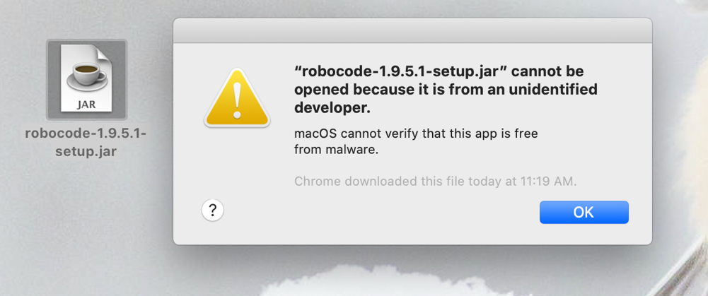
  + On mac you can get around this by control clicking the jar file, and hitting open
    - 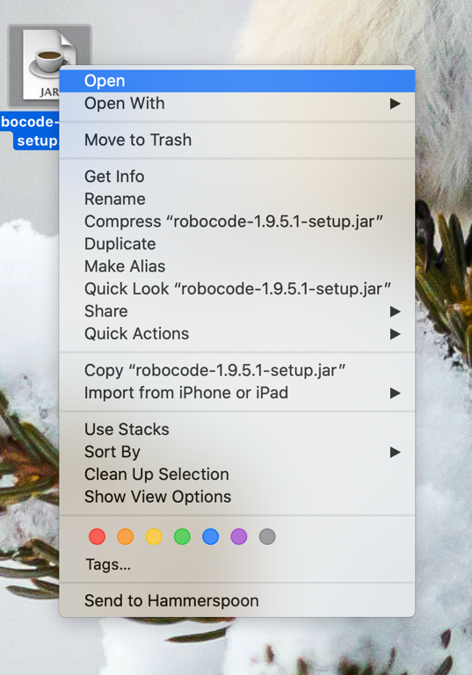
  + If you have trouble on windows, you may have to do something like this: <https://stackoverflow.com/questions/37105012/execute-jar-file-as-administrator-in-windows>
* Follow instructions to setup:
  + Select NO if you want a different setup path.
    - 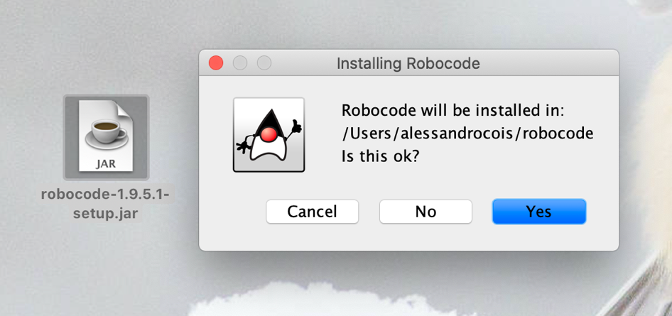
    - 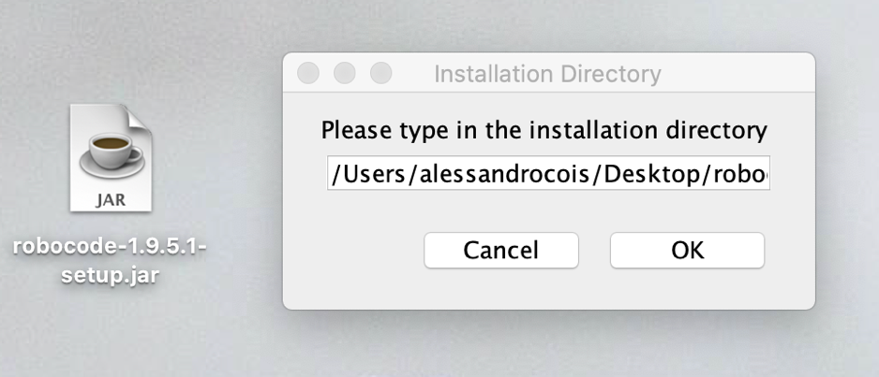
  + Follow the rest of the instructions, you should see success at the end if all went well.
    - 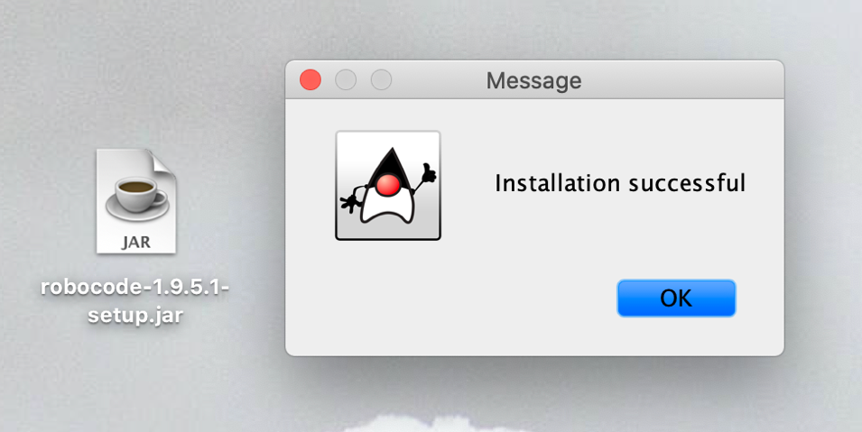

## Run on Mac

* Run robocode, by double clicking “robocode.sh”
  + - 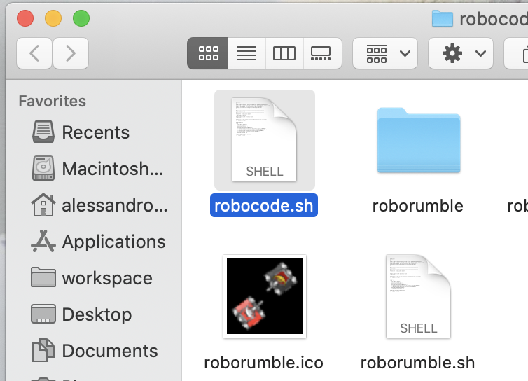
  + Alternatively, if that doesn’t work, you can run it from the terminal
    - 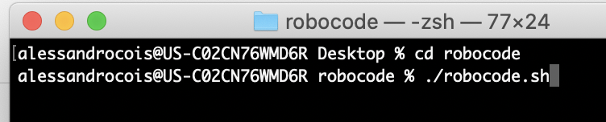

## Run on Windows

* **On Windows:** Run the “robocode.bat” file. You may need to open up a terminal to do that.

## Verify it is running

* You should see a splash screen, then the application pop up!
  + It will run a battle, in a window like this.
  + A screenshot of a computer

    Description automatically generated

## Run Battle in Robocode

* Run your first battle
  + Select Battle from the top menu, and click “New
    - 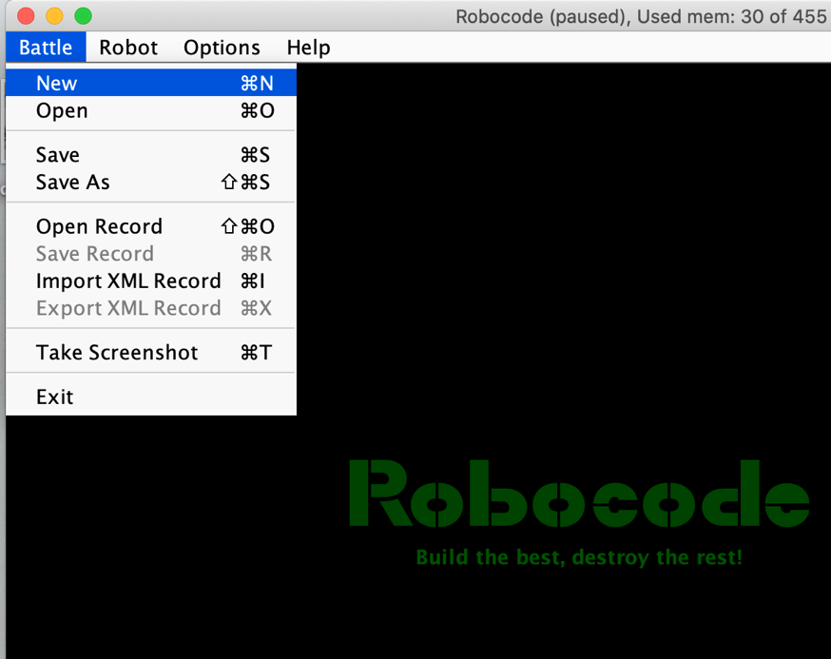
  + Add a few sample robots to your battle, then click start battle at the bottom!
    - A screenshot of a computer

      Description automatically generated
  + A battle should pop up and play out! Yay!
    - 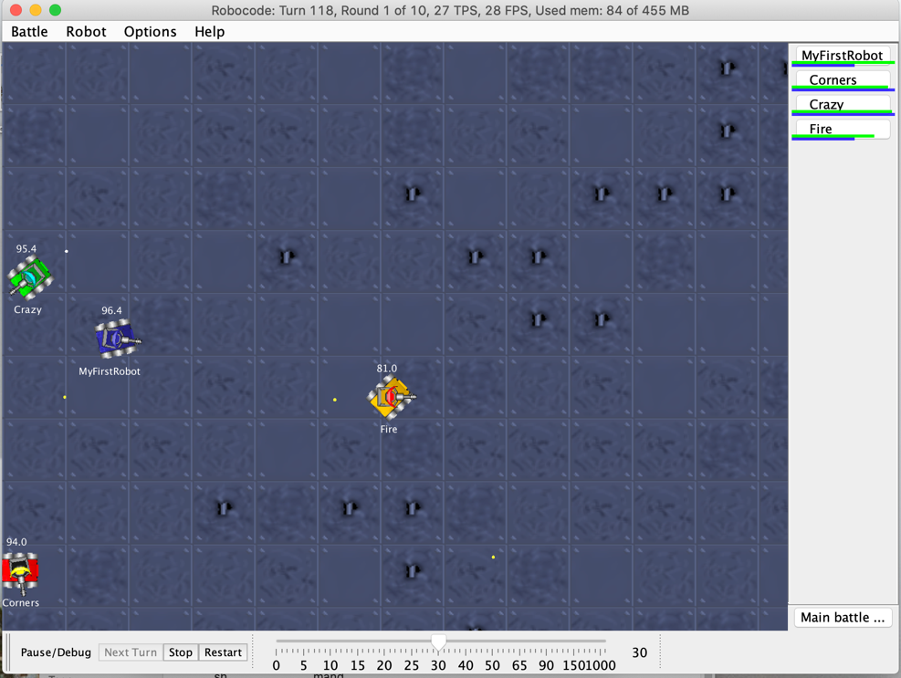

# Setup Development With Intellij

* If you do not care about debugging, autocomplete or your intellij hotkeys, you can use the built in editor. (Not recommended) See instructions here <https://robowiki.net/wiki/Robocode/My_First_Robot>

## Open Intellij Project

* In intellij, “open” a project.
* Select the folder “intellijDevelopment” located inside the git repo you cloned.
  + - A screenshot of a computer

      Description automatically generated

## 

## Setup Robocode Libraries

* **Open module settings for your top folder**
  + - A screenshot of a computer

      Description automatically generated
* **Go to the libraries section, and add a “Java” library**
  + - A screenshot of a computer

      Description automatically generated
* **Add both the “Javadoc” and “libs” folder**
  + - A screenshot of a computer

      Description automatically generated
* **Your “Libraries” should look like this. (Don’t worry about Name).**
  + - A screenshot of a computer

      Description automatically generated
* **Your “Modules” should look like this**
  + - A screenshot of a computer

      Description automatically generated
* **Click Apply + Okay at the bottom.**

## Build your project

* In your intellij project, you should see src/gvconnect/team1_theKoolKidsBot
* Click the hammer “Build Project” (Compile your project).
* Verify you see “team1_theKoolKidsBot” in the out/production/robocodeIntellij/gvconnect folder
  + - A screenshot of a computer

      Description automatically generated

# Point Robocode to your complied intellij output

## Go to Development options

* In robocode, Go to options > preferences in the menu
  + - 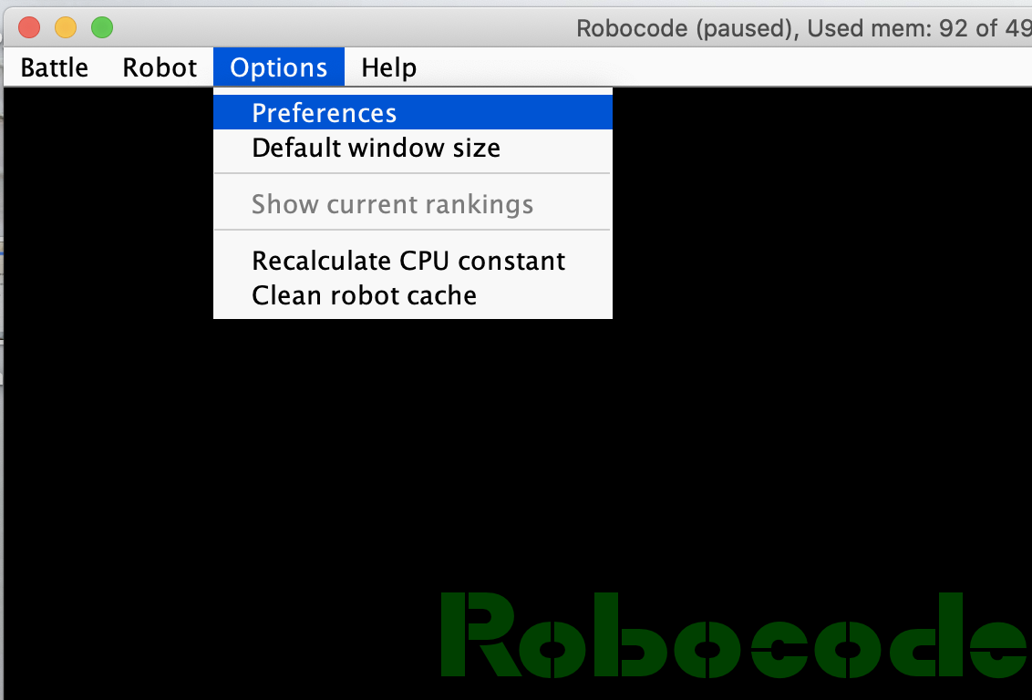

## Add path to intellij’s output

* Add path to:

**…/gvconnect_robocode/intellijDevelopment/out/production/robocodeIntellij**

* The exact path is important. (One folder too high or low will cause issues).
  + - A screenshot of a computer

      Description automatically generated

## Make new battle with your bot

* Hit finish and go create a new battle. After hitting Cmd + R, you should see your new bot! You can add it and battle with it.
  + A screenshot of a computer

    Description automatically generated

# Setup Intellij Debugging

## Close robocode

* Close robocode. Intellij is going to open it later.

## Open and edit pre-existing run configuration

* In Intellij, you should already see a run configuration. We need to modify it. Hit “Edit Configurations”A screenshot of a computer

  Description automatically generated

## Fix “Working Directory” in Run Configuration

* “working directory” must be changed to: path/where/you/installed/robocode (not the intellij project)
  + - 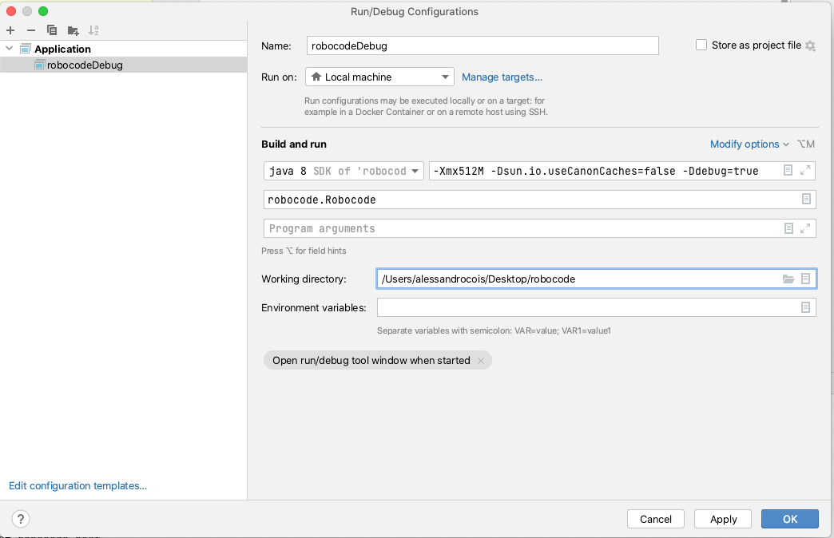

## Run debug with breakpoints

* Add some breakpoints to your robot.
* Now hit debug.
  + A screenshot of a computer

    Description automatically generated
* Robocode should pop up! Run a new battle with your robot, and a sample one.
* When the battle runs, and your bot code hits a breakpoint, the battle will pause and you can debug!
  + 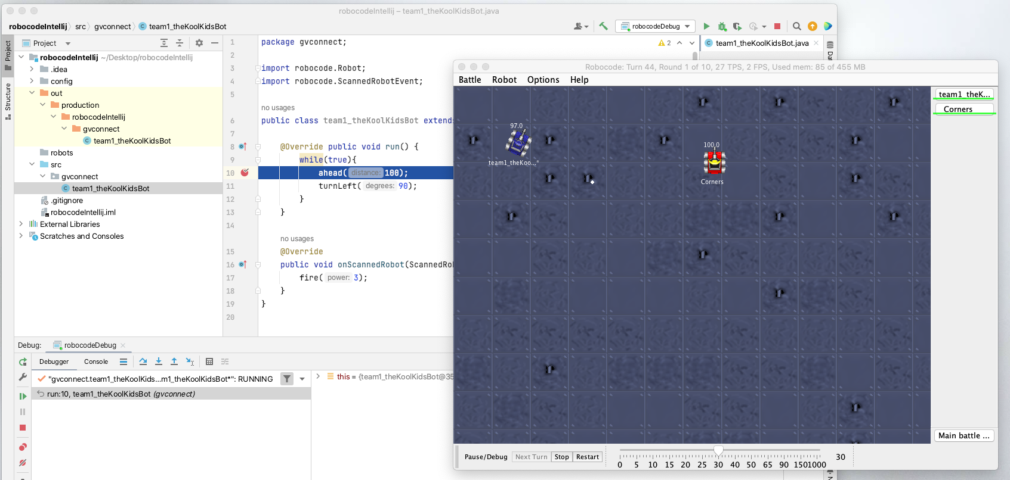
* If you can debug your robot, you are fully set to develop. Happy coding

# Tournament Rules

## Robocode Rules

We will be having a melee tournament. Meaning bots will fight on a 1000x1000 grid, with 10 bots total on the screen.

<https://robowiki.net/wiki/Melee>

When creating a new battle, hit the rules tab at the top, set your board to 1000x1000 so you can test your bots in the correct space!

You also may want to set number of rounds to 1 for testing.

Leave the other rules as default.

Your robot may only extend “Robot” or “AdvancedRobot”.

Do not implement “BorderSentry” or “Droid”.

## Scoring

Scoring will be based on the “Total Score” at the end of the rounds. This can be seen in a pop-up once all rounds are over.

<https://robowiki.net/wiki/Robocode/Scoring>

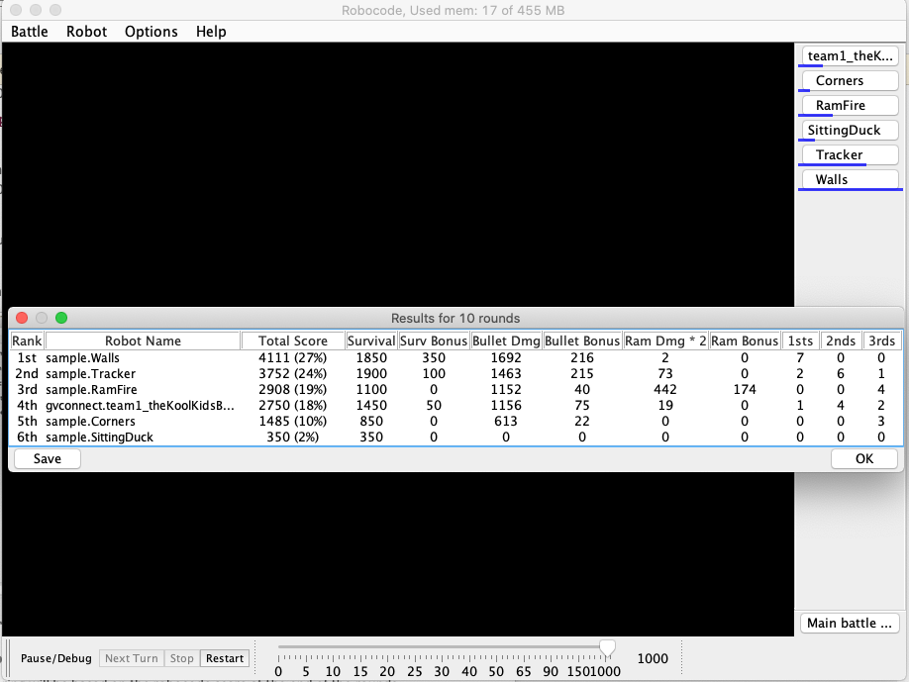

## Tournament bracket

There are 60 teams. 10 robots will fight at a time. There will be 6 winners in the first round.

Then we will fight those 6 winners against each other to decide our champion.

# Useful links

Start with -> Wiki FAQ - <https://robowiki.net/wiki/Robocode/FAQ>

API - <https://robocode.sourceforge.io/docs/robocode/>

Melee Strategy - <https://robowiki.net/wiki/Melee_Strategy>

Wiki home page - <https://robowiki.net/wiki/Main_Page>